**TANC 10 SPEAKING TEST**

SAMPLE ( BÀI TRẢ LỜI MẪU)

Part 1: Question

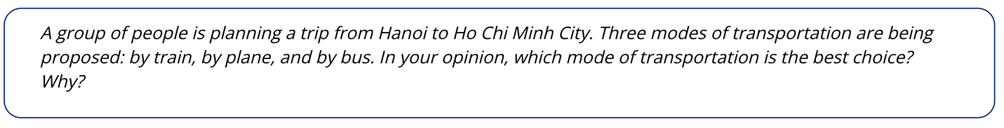

Sample answers:

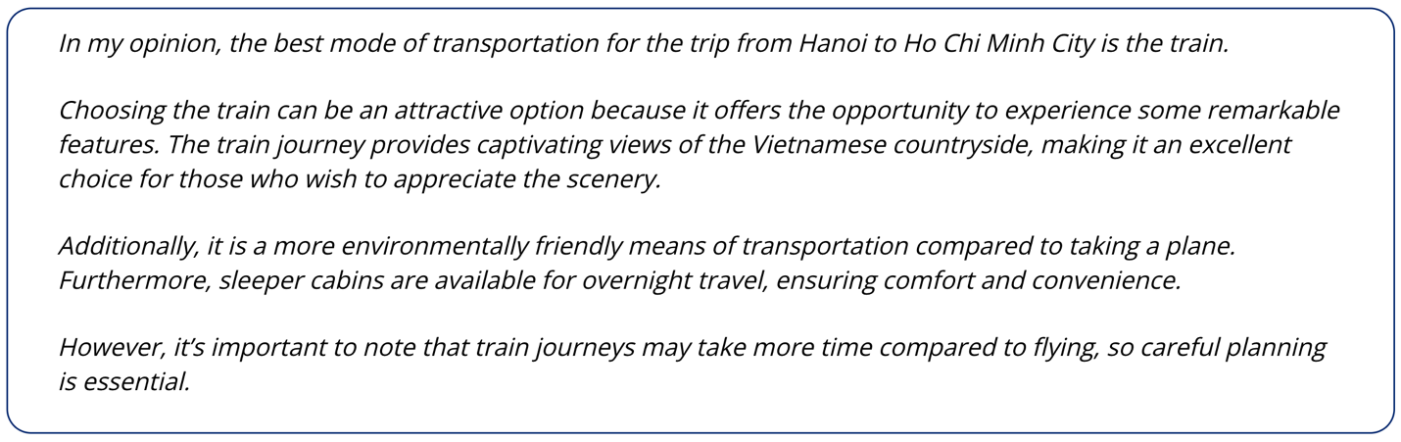

Part 2: Question

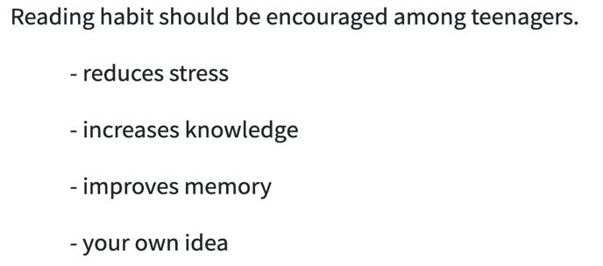

Sample answers

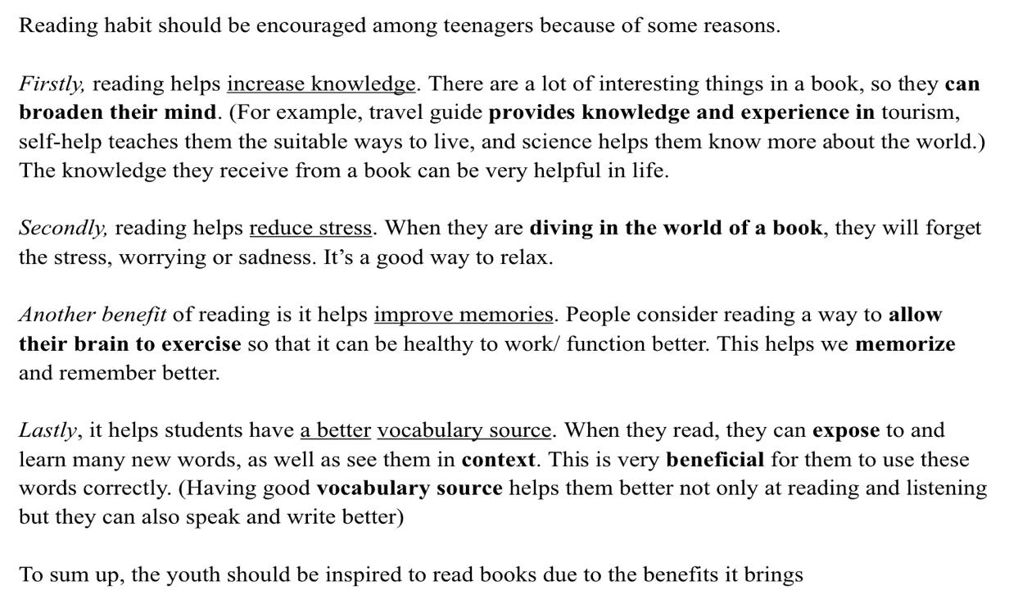

Test 1

**Part 1** SOLUTION DISCUSSION

You are planning your holiday. There are three suggestions: a beach holiday, a climbing

holiday, and a sight-seeing holiday. Which do you think is the best choice for you?

**Part 2** TOPIC DEVELOPMENT

The reasons why mobile phones are useful tools at schools.

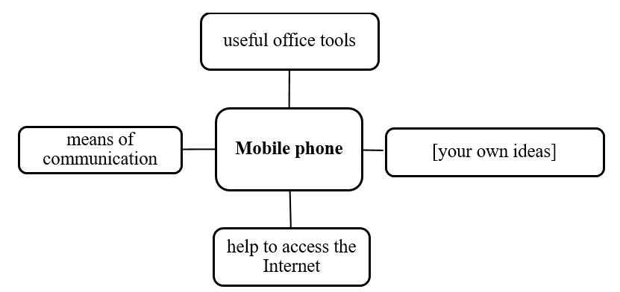

**Test 2**

**Part 1** SOLUTION DISCUSSION

Your friend wants to take up a new hobby. He is considering three activities: doing

yoga, playing the piano and joining a charity club. Which do you think is the best

choice for him?

**Part 2** TOPIC DEVELOPMENT

Why visiting a foreign country is a valuable experience for people.

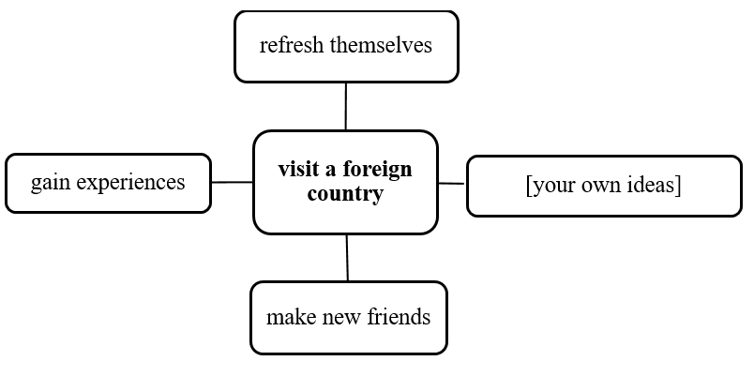

**Test 3**

**Part 1** SOLUTION DISCUSSION

A group of friends are hanging out in their free time. Three ideas are suggested: go to

eat something (food), go shopping and go to the cinema. Which is the best choice?

**Part 2** TOPIC DEVELOPMENT

Why online learning is beneficial to students.

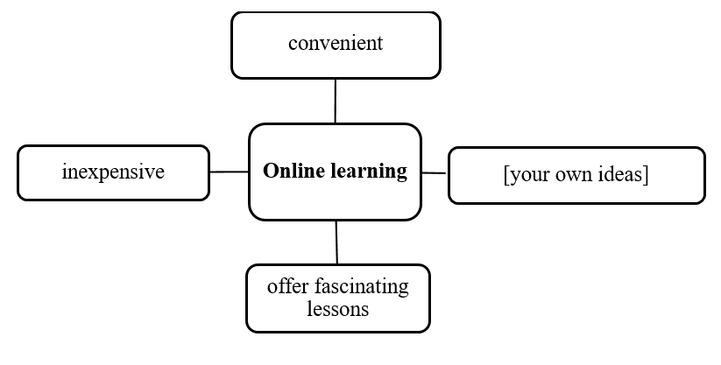

CÁC BẠN CHUẨN BỊ 3 ĐỀ NHỮ MẪU CÔ CÓ HƯỚNG DẪN Ở TRÊN, MỖI BẠN SẼ HOÀN THÀNH 2 PHẦN CÂU HỎI THEO ĐỀ, ĐI THI BỐC TRÚNG ĐỀ NÀO THÌ SẼ TRẢ LỜI THEO ĐỀ ĐÓ.